What are tensors?

tensors are just multidimensional arrays, that allows you to represent data having higher dimensions.

What is tensorflow?

the name “TensorFlow” has been derived from the operations which neural networks perform on tensors. It’s literally a flow of tensors.

Basically, the overall process of writing a TensorFlow program involves two steps:

1. Building a Computational Graph

2. Running a Computational Graph

In TensorFlow, constants, placeholders and variables are used to represent different parameters of a deep learning model.

**Constants:**

Constants are initialized when you call tf.constant, and their value can never change

**Placeholder:**

A TensorFlow constant allows you to store a value but, what if, you want your nodes to take inputs on the run? For this kind of functionality, placeholders are used which allows your graph to take external inputs as parameters. Placeholders are not initialized and contains no data.

### ****Variables****

In deep learning, placeholders are used to take arbitrary inputs in your model or graph. Apart from taking input, you also need to modify the graph such that it can produce new outputs w.r.t. same inputs

Basic program:

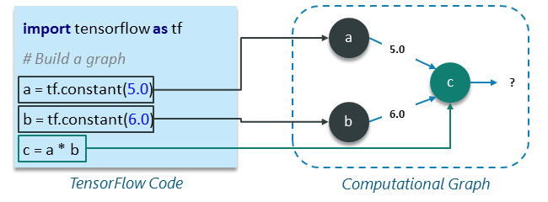

SESSION:

in order to get the output of node c, we need to run the computational graph within a **session**.

A session encapsulates the control and state of the TensorFlow runtime i.e. it stores the information about the order in which all the operations will be performed and passes the result of already computed operation to the next operation in the pipeline.

## **Linear Regression Model Using TensorFlow**

Linear Regression Model is used for predicting the unknown value of a variable (Dependent Variable) from the known value of another variables (Independent Variable) using linear regression equation as shown below:

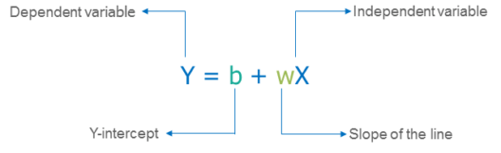

there are two more things left to be added in this model to make it a complete regression model:

* First, we need to provide a mechanism by which our model can train itself automatically based on given set of inputs and respective outputs.
* Second thing that we need is to validate our trained model by comparing its output with the desired or target output based on given set of x values.

### ****Loss Function – Model Validation****

A loss function measures how far apart the current output of the model is from that of the desired or target output.

 linear regression model called as Sum of Squared Error or SSE:

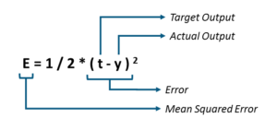

If we are getting a high loss value. Therefore, we need to adjust our weights (W) and bias (b) so as to reduce the error that we are receiving.

### ****tf.train API – Training the Model****

TensorFlow provides **optimizers** that slowly change each variable in order to minimize the loss function or error.

The simplest optimizer is **gradient descent**. It modifies each variable according to the magnitude of the derivative of loss with respect to that variable.